**Code Smell – 3**

**Large Class**

This code smell occurs when the class is bigger then it is supposed to be.

**Code Snippet:**

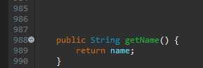

**Code Location:**

The classe is in the folloying path:

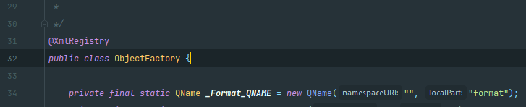“*src-gen\main\java\org\jabref\logic\importer\fileformat\medline\ObjectFactory*”

**…**

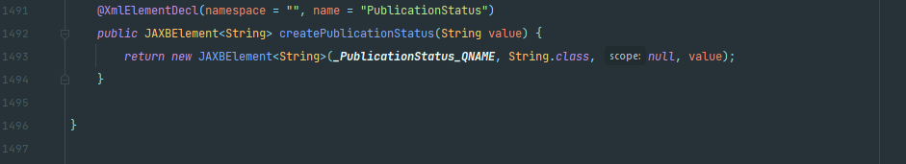

**Justification:**

As shown in the images, the class ObjectFactory is much bigger than the normal (1497).

**Refactoring proposal:**

The class ObjectFactory is used for the Factory Pattern (used to hide the creation of objects). However, it should be subdivided in smaller factories so we don’t have class with 1497 lines.